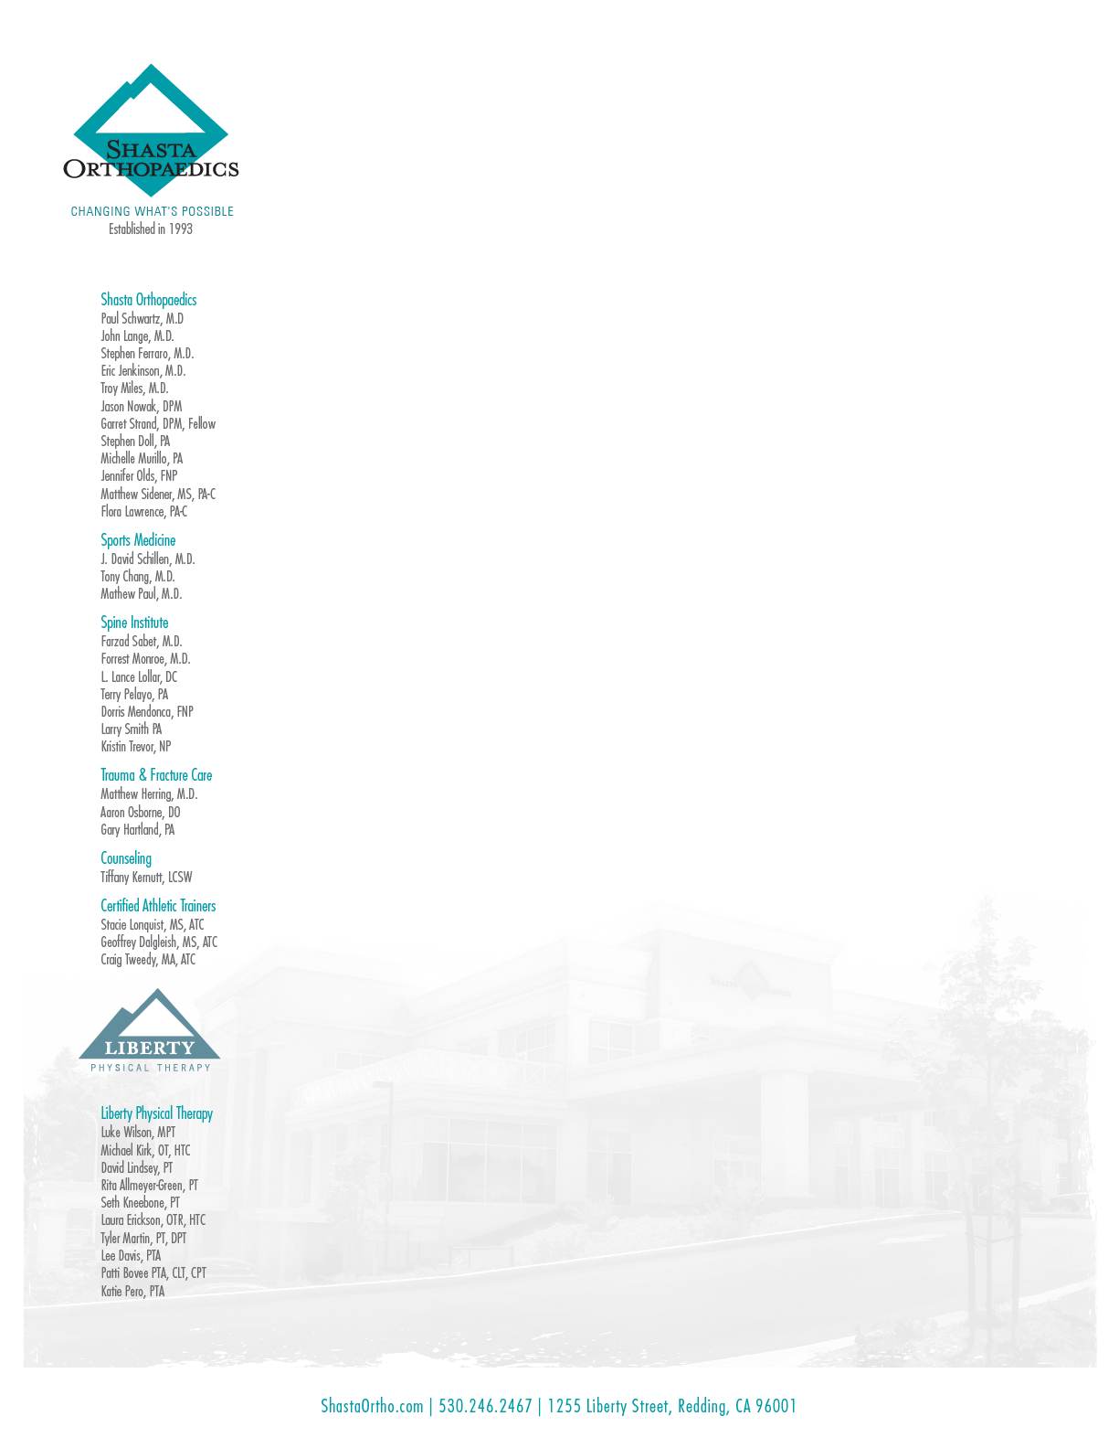

RE: Brian Blackburn, D.O.

February 2021

Dear ______________,

On behalf of Shasta Orthopaedics we regret to inform you that Dr. Blackburn will be leaving our Group at the end of February 2021. This should not affect the continuity or quality of your care as Dr. Blackburn will be staying in the community and joining the group of providers at Dignity Health Care.

Dr. Blackburn’s new office will be at 2510 Airpark Drive, Suite 301, Redding, California, 96001 and his office phone number is (530) 242-3500.

Dr. Blackburn’s departure in no way effects your relationship or treatment with any of the other providers at Shasta Orthopaedics. Your medical record will remain in the custody of Shasta Orthopaedics.

For your convenience as well as the continuity and quality of your care arrangements have been made for Dr. Blackburn to continue to have to access to your medical records. If you want Dr. Blackburn to receive a copy of your records please contact Professional Medical Copy at (530) 241-2971 or email them at helpteam@promedcopy.com.

Dr. Blackburn joined Shasta Orthopaedics in 2019 and has been instrumental in the continued development of our Spine Institute. We appreciate the care that Dr. Blackburn has provided the patients of our community and his service with Shasta Orthopaedics.

I know you join Shasta Orthopaedics in wishing Dr. Blackburn the very best of luck.

If you have any questions you may contact Dr. Blackburn’s new office at (530) 242-3500 or call us at (530) 246-2467.

Sincerely,

Paul E. Schwartz, M.D.

President, Shasta Orthopaedics

Brian Blackburn, D.O.

Spine Surgeon